World robotics tournament fields two teams from Millikan Science Academy
by Monica Carazo | Apr 15, 2016 | Achievements, Magnets, Special Events, STEM, Technology | 0 comments
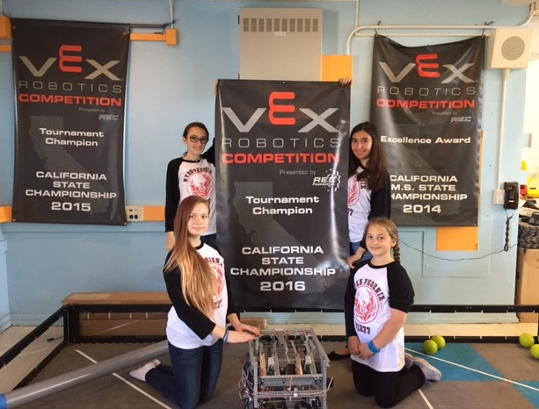
Above, Nyan Phoenix members, clockwise from top left, Zoe Utsler, Lucy Minasyan, Haley Brooks and Catherine Vess-Ovsiannkov display the tournament banners won by robotics teams at Millikan Science Academy.
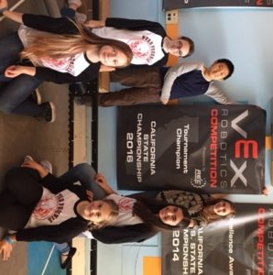
Two teams from Millikan Science Academy will be competing at VEX World. The are, at top, Micro Stars Albert Zhang and Margo Dayan, and Nyan Phoenix members Zoe Utsler, Lusine Minasyan, Haley Brooks and Catherine Vess-Ovsiannkov.
Two robotics teams from Millikan Science Academy, including one that is internationally ranked, will be competing next week at VEX Worlds, a tournament that tests the design and programming skills of accomplished STEM students.
Nyan Phoenix – whose members are seventh-graders Haley Brooks and Zoe Utsler and eighth-graders Lucy Minasyan and Catherine Vess-Ovsiannkov – is ranked 18th in the world for middle school robotics teams, and is seeded sixth for the VEX contest.
Also competing at VEX Worlds is a two-member team from Millikan called the Micro Stars. Seventh-graders Margo Dayan and Albert Zhang won the VEX in the Valley tournament, as well as the state title at the California VEX Championships.
“To see these kids interact, work together, prepare, excel together and fail together is amazing,” said Carlos Lauchu, the Science Academy director.
Robotics also teaches students about good sportsmanship and resiliency – attributes demonstrated by Nyan Phoenix when the students’ newly redesigned robot, “Double the Trouble,” malfunctioned midway through last weekend’s U.S. Open Robotics Championships in Iowa.
“They are setting an example for others, including adults, and showing people that you can work together in harmony even with disagreements and still come out ahead – whether you win or lose,” said Lauchu, who coaches the robotics teams.

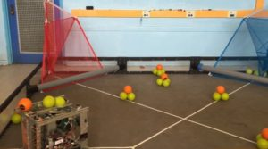

Click the image to see ‘Double the Trouble,’ the Nyan Phoenix robot, in action.
The Science Academy is a new magnet program at Millikan Middle School in Sherman Oaks, which also has a performing arts magnet. Although they are still years away from college, students can jump-start their career ambitions through the rigorous science, technology, engineering and math curriculum.
Nyan Phoenix teammates Lucy and Catherine, for example, aspire to be engineers, while Micro Star Margo has set her sights on a career at the Jet Propulsion Laboratory. They will be able to utilize the skills they are perfecting through their participation in robotics.
“The robotics program is important because all humans are relying on technology more and more,” Margot said.
Robotics students design, build and program their robots, which must be capable of both autonomous and remote-controlled play. This year’s VEX tournament features a game called “Nothing But Net,” a strategic game in which competing teams try to rack up the most points by using their robots to hurl balls into small nets on a 12-by-12-foot court.
“We all have the same passion for robots,” Catherine said. “Plus, this is a once-in-a-lifetime experience.”
Millikan last year sent two teams to the state robotics tournament – Parrallax, which was a finalist, and Quantum Flux, which took first place – and is excited to be sending two teams to vie for the VEX Worlds title.
“Congratulations to our talented teams heading to VEX Worlds,” said School Board Member Scott Schmerelson, who represents Millikan. “What each of you has accomplished is amazing, and I’m sure it’s only the beginning of an illustrious school career. We are proud of you and we know you’ll represent LAUSD with the hearts of champions.”

